Chirton School Home Learning Project Easter 2022
Due back by Thursday 28th April 2022
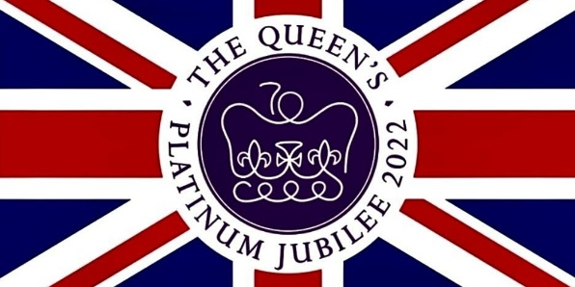

Dear Children,
As you might be aware, Her Majesty the Queen celebrates 70 years of service, known as a Platinum Jubilee, in 2022.
The Queen is very keen on tree planting and has even created a special ‘Green Canopy’ initiative this year, which will encourage tree planting all over the country; as a Forest School, this is something we of course whole-heartedly support!
Therefore, your challenge over the next three weeks is to create a new species of tree that can be placed into a special ‘Chirton School’ book and sent to the Queen!
Your design will need to fit onto an A4 page and may include collage, crayons, paint and labels/descriptions. Your tree might grow hearts, chocolates, footballs or photographs – be as creative as you like!
Remember to continue to read as much as possible during the holidays and take your time on this project – you can ask us any questions you might have, but don’t leave it until the last minute!
Have fun and happy Easter!


Love Mrs Bekker Wrench and team x
