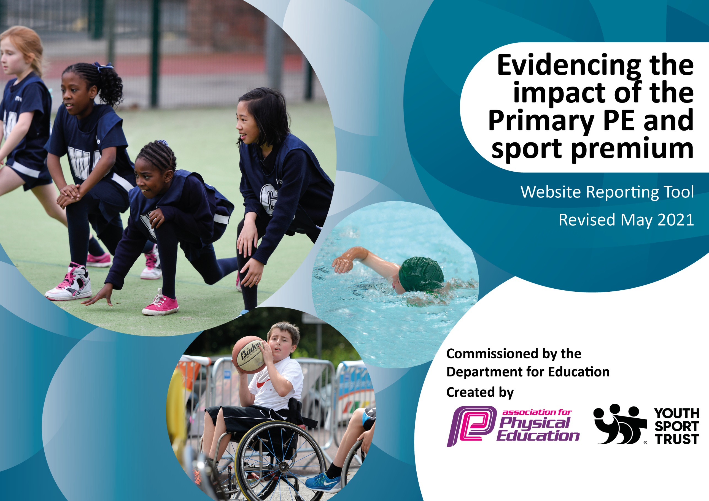
100

It is important that your grant is used effectively and based on school need. The Education Inspection Framework (Ofsted 2019 p64) makes clear there will be a focus on ‘whether leaders and those responsible for governors all understand their respective roles and perform these in a way that enhances the effectiveness of the school’.

Under the Quality of Education criteria (p41) inspectors consider the extent to which schools can articulate their curriculum (INTENT), construct their curriculum (IMPLEMENTATION) and demonstrate the outcomes which result (IMPACT).

To assist schools with common transferable language this template has been developed to utilise the same three headings which should make your plans easily transferable between working documents.

Schools must use the funding to make additional and sustainable improvements to the quality of Physical Education, School Sport and Physical Activity (PESSPA) they offer. This means that you should use the Primary PE and sport premium to:

- Develop or add to the PESSPA activities that your school already offer
- Build capacity and capability within the school to ensure that improvements made now will benefit pupils joining the school in future years
- The Primary PE and sport premium should not be used to fund capital spend projects; the school’s budget should fund these.
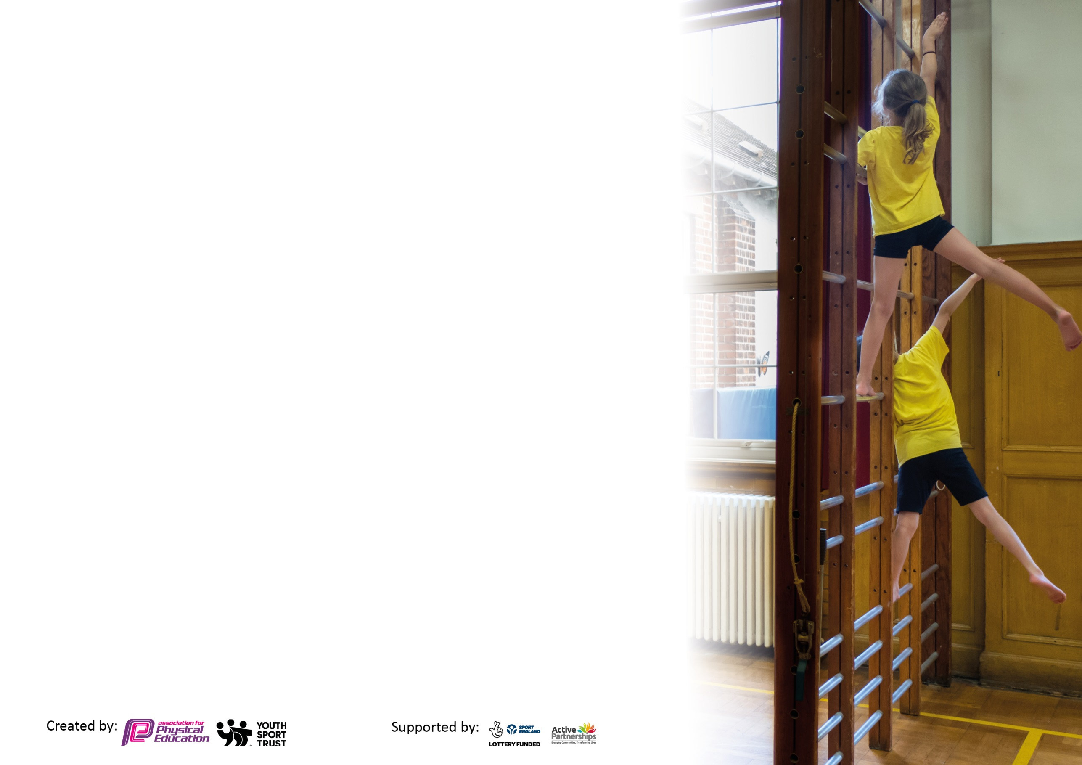
Please visit gov.uk for the revised DfE guidance including the 5 key indicators across which schools should demonstrate an improvement. This document will help you to review your provision and to report your spend. DfE encourages schools to use this template as an effective way of meeting the reporting requirements of the Primary PE and sport premium.

We recommend you start by reflecting on the impact of current provision and reviewing the previous spend.

Schools are required to publish details of how they spend this funding, including any under-spend from 2025/2026, as well as on the impact it has on pupils’ PE and sport participation and attainment by the end of the summer term or by 31st July 2026 at the latest.

We recommend regularly updating the table and publishing it on your website throughout the year. This evidences your ongoing self-evaluation of how you are using the funding to secure maximum, sustainable impact. Final copy must be posted on your website by the end of the academic year and no later than the 31st July 2026. To see an example of how to complete the table please click HERE.



Support for review and reflection - considering the 5 key indicators from DfE, what development needs are a priority for your setting and your pupils now and why? Use the space below to reflect on previous spend and key achievements and areas for development.
Key achievements to date until July 2026: | Areas for further improvement and baseline evidence of need:
- Exposure to elite sport (Wimbledon, Cricket World Cup)  - EQUA Secondary School Primary PE offer.  - Dauntsey School outreach.  - Real PE SOW.  - Continued development of covered outdoor area, ‘The Heart.’  - SEND Colour Rush event.  - EQUA SEND sports event.  - Autumn Fair cross-trust Football Tournament.  - Annual Race for Life from age 2-11.  - Tennis coaching.  - Roll-out of the ‘Playtime Project.’ | - Develop application of ABCs into sport and game scenarios (Achieved)  - Increase exposure to individual sports including gymnastics, dance and athletics (partially achieved through implementation of ‘The Heart’ building)  - Audit and restock PE shed (Achieved)  - Audit and continue to restock ‘Playtime Project’ shed.  - Prepare spare PE kit bags (Achieved)  - Relaunch and reorganise swimming offer (Achieved)  - Reassign Sports Ambassadors/Leaders through ‘Playtime Project.’  - Review PE curriculum offer; monitoring, assessment and coverage.

Did you carry forward an underspend from 2024-25 academic year into the current academic year? YES/NO * Delete as applicable
Total amount carried forward from 2024/2025 £0
+ Total amount for this academic year 2025/2026 £16,750
= Total to be spent by 31st July 2026 £16,750
Meeting national curriculum requirements for swimming and water safety.  N.B Complete this section to your best ability. For example you might have practised safe self-rescue techniques on dry land which you can transfer to the pool when school swimming restarts.  Due to exceptional circumstances priority should be given to ensuring that pupils can perform safe self-rescue even  if they do not fully meet the first two requirements of the NC programme of study. | All children to have completed swimming lessons during terms 5/6 which will include water safety and self-rescue where applicable.
What percentage of your current Year 6 cohort swim competently, confidently and proficiently over a distance of at least 25 metres?  N.B. Even though your pupils may swim in another year please report on their attainment on leaving primary school at the end of the summer term 2024.  Please see note above. | 85% (11/13)
What percentage of your current Year 6 cohort use a range of strokes effectively [for example, front crawl, backstroke and breaststroke]?  Please see note above. | 85% (11/13)
What percentage of your current Year 6 cohort perform safe self-rescue in different water-based situations? | 85% (11/13)
Schools can choose to use the Primary PE and sport premium to provide additional provision for swimming but this must be for activity over and above the national curriculum requirements. Have you used it in this way? | No

Action Plan and Budget Tracking
Capture your intended annual spend against the 5 key indicators. Clarify the success criteria and evidence of impact that you intend to measure to evaluate for pupils today and for the future.

Academic Year: 2025/26 | Total fund allocated: £16, 750 | Date Updated: July 2026
Key indicator 1: The engagement of all pupils in regular physical activity – Chief Medical Officers guidelines recommend that primary school pupils undertake at least 30 minutes of physical activity a day in school |  |  |  | Percentage of total allocation:
 |  |  |  | 1.79%
Intent | Implementation |  | Impact
Your school focus should be clear what you want the pupils to know and be able to do and about  what they need to learn and to  consolidate through practice: | Make sure your actions to achieve are linked to your intentions: | Funding allocated: | Evidence of impact: what do pupils now know and what can they now do? What has changed? | Sustainability and suggested next steps:
- Hour PE lesson each week  - 2 hours of FS learning a week.  - Active curriculum  - KS2 school swimming  - After school club offer  - Inter-school competitions | - Timetabled hour of PE a week.  - Spare PE kits  - Active lessons  - Range of clubs offered  - Widen range of playtime equipment (’Playtime Project’)  - School Council Playtime resources | £300 | - Living out a healthy lifestyle  - Greater enjoyment and participation in sport.  - Inclusive approach.  - Pupils challenged and supported.  - Young people have potential to enjoy and achieve within PE through quality personalised opportunities. | - Clubs tailored to pupil voice.  - All staff aware of resources for active breaks and wet playtimes/lunchtimes.  - All children to attend at least one active club per academic year.
Key indicator 2: The profile of PESSPA being raised across the school as a tool for whole school improvement |  |  |  | Percentage of total allocation:
 |  |  |  | 0.75%
Intent | Implementation |  | Impact
Your school focus should be clear what you want the pupils to know and be able to do and about  what they need to learn and to  consolidate through practice: | Make sure your actions to achieve are linked to your intentions: | Funding allocated: | Evidence of impact: what do pupils now know and what can they now do? What has changed?: | Sustainability and suggested next steps:
- Principles of Real PE to link SEMH across the school  - PE objectives linked to School Values  - Values displayed  - Purchase new resources  - Trophy cabinet displaying awards prominently.  - House competitions. | - Values demonstrated in lessons and competitions.  - Pupil led worships. | £126 | - Improved attitudes and confidence.  - Raised profile of PE. | - Improved Celebration of sporting achievements.  - Sports Leaders/Ambassadors linked to ‘Playtime Project.’

Key indicator 3: Increased confidence, knowledge and skills of all staff in teaching PE and sport |  |  |  | Percentage of total allocation:
 |  |  |  | 3%
Intent | Implementation |  | Impact
Your school focus should be clear | Make sure your actions to | Funding | Evidence of impact: what do | Sustainability and suggested
what you want the pupils to know | achieve are linked to your | allocated: | pupils now know and what | next steps:
and be able to do and about | intentions: |  | can they now do? What has
what they need to learn and to |  |  | changed?:
consolidate through practice:
- Quality of PE is consistently good.  - Governor monitoring (community and celebration)  - Continue to enhance the knowledge, confidence and skills of staff to ensure the quality of PE is consistently good or higher across the school.  - Through specialist support, provide CPD opportunities (hockey, rounders, tennis, multi-skills, swimming) | - PE coach to teach alongside members of staff.  - Use progression of skills document to support planning.  - Differentiated learning outcomes for pupils (familiar across the curriculum) | £500 | - An improved attitude towards PE by all.  - Staff members confident to lead sports clubs after school.  - ‘Team of Experts’ raise in confidence in monitoring and assessing PE. | - Team teach across year groups/classes.
Key indicator 4: Broader experience of a range of sports and activities offered to all pupils |  |  |  | Percentage of total allocation:
 |  |  |  | 94%
Intent | Implementation |  | Impact
Your school focus should be clear | Make sure your actions to | Funding | Evidence of impact: what do | Sustainability and suggested
what you want the pupils to know | achieve are linked to your | allocated: | pupils now know and what | next steps:
and be able to do and about | intentions: |  | can they now do? What has
what they need to learn and to |  |  | changed?:
consolidate through practice:
- Improved attitudes and participation in PE and sporting activities.  - More opportunities will be available for children to experience. | - Purchase equipment for new sports e.g. badminton, orienteering and seated volleyball; a better range of activities available at break times.  - Broad range of clubs offered, with activities available before and after school (link to Eco-Schools work – Gardening)  - Further develop ‘The Heart’ for indoor PE (plastic protection boards, mats, TV screen)  - Joy Class garden development. | £15,874 | - Through increased experiences and opportunities, children are happily busy and occupied at break times.  - All pupils are active and healthy.  - There are improved opportunities for indoor PE (gym and dance) | - Introduce new activities and games from other cultures.

Key indicator 5: Increased participation in competitive sport |  |  |  | Percentage of total allocation:
 |  |  |  | 1.2%
Intent | Implementation |  | Impact
Your school focus should be clear | Make sure your actions to | Funding | Evidence of impact: what do | Sustainability and suggested
what you want the pupils to know | achieve are linked to your | allocated: | pupils now know and what | next steps:
and be able to do and about | intentions: |  | can they now do? What has
what they need to learn and to |  |  | changed?:
consolidate through practice:
- Pupils develop their sportsmanship, focusing on our core school values and learning behaviours.  - Greater opportunities are provided to pupils so that they have the confidence to lead, manage and officiate. | - Compete in Trust-wide competitions and events.  - Hold House-days across the year.  - Competitive sports day.  - ‘Playtime Project’ and ‘Neighbourhood Watch’ schemes. | £200 | - 100% of children participate in competitive sport.  - All pupils value the opportunity to partake in competitive sport.  - House points are valued and are linked to global charities; trophies are gracefully received. A friendly, team mentality is evident across the school. | - Sports leaders/ambassadors run competitions and games at break times.

Signed off by
Head Teacher: | Amy Bekker Wrench
Date: | July 2026
Subject Leader: | Whole Team
Date: | July 2026
Governor: | Claire Clever
Date: | July 2026

